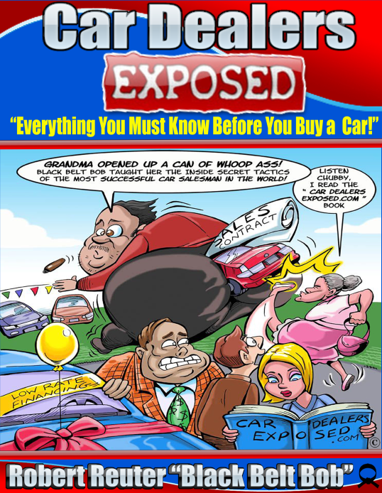
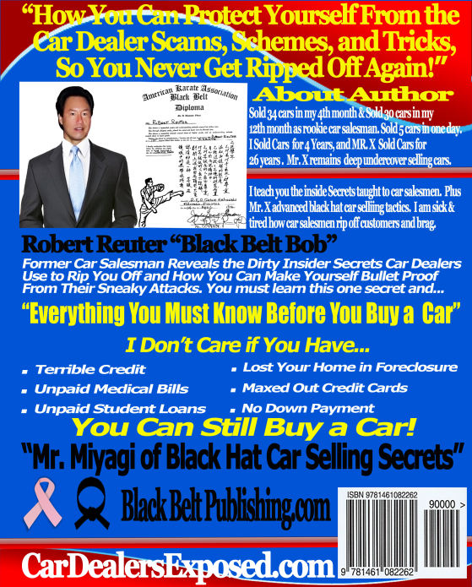

Car Dealers Exposed: Everything You Must Know Before You Buy a Car!

Robert L Reuter
“Black Belt Bob”



www.CarDealersExposed.com
Robert L Reuter Copyright © 2011 All Rights Reserved


Attention: Car Shoppers, Do Not Step foot on a car dealership without knowing the sneaky, underhanded tricks, the salesmen use to rip you off. I’m going to share with you the insider secrets, that I learned to work in the car industry, and it’s going to make you furious!

"How You Can Protect Yourself From Their Scams, Schemes, and Tricks, So You're Never Ripped Off Again!"

Former car salesman reveals the dirty insider secrets car dealers use to rip you off and how you can make yourself bullet proof from their sneaky attacks.

I don't care if YOU have...
- Terrible credit
- Unpaid medical bills
- Unpaid student loans
- Lost your home in foreclosure
- Maxed out credit card limits
- No Down Payment

YOU Can Still Buy a Car!

Visit http://www.CarDealersExposed.com You get digital version of my book, 23 Step by Step Video Tutorials (Watch Over My Shoulder), Audio, PDF Blueprints, 3 Fast Action Bonuses and Grab Bag Surprise Software.
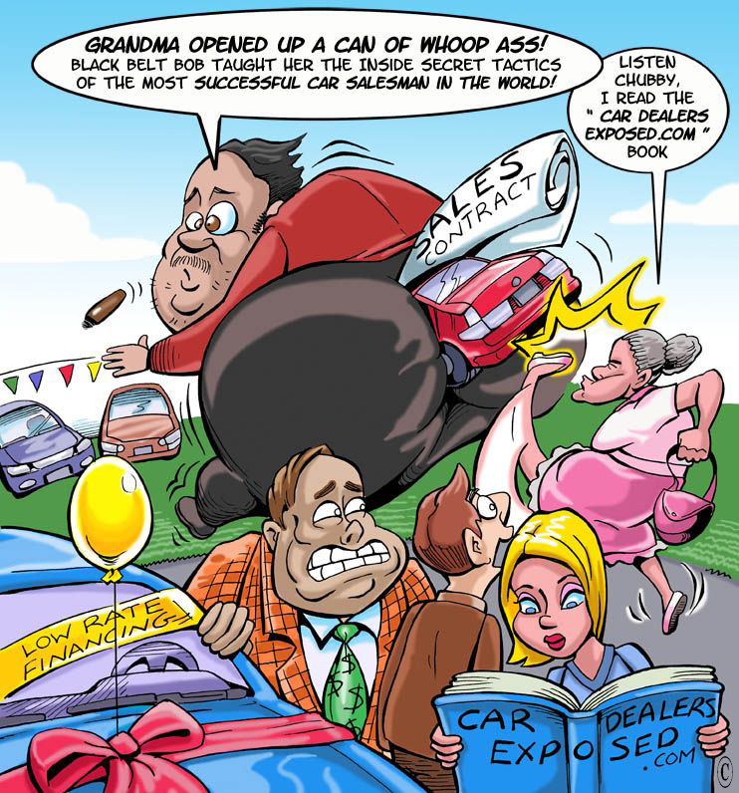
Car Dealers Exposed - Copyright 2011 © Robert L Reuter All Rights Reserved
Car Dealers Exposed - Copyright 2011 © Robert L Reuter All Rights Reserved
Legal Disclaimer

The entire contents of this book are protected by international copyright laws. No portion of this publication may be produced or transmitted in any form without the written permission of the author Robert L Reuter. Media, TV, Radio, Magazine, Newspapers can contact the author if they want to conduct an interview. The author is willing to be a guest on radio and media shows to help their audience with excellent content with questions and answers.

The information in this book, stories, opinions, case studies, secret tips, examples, illustrations and photographs is intended for the personal use of the reader so they can conduct their own research when buying a new or used car. The information is based on the opinions of the author and those opinions he interviewed. These opinions are to make you aware of what has happened in the past which could happen in the future. It is up to you to make the final opinion before you purchase any automobile. If you apply the many techniques in this book, it will help you make the best decision, subject to the research you conduct, when you buy a new or used car. It’s your responsibility to evaluate the accuracy or all opinions inside this book. The author and publisher shall not be liable for any cost or damage based on the opinions inside this book. Cars have many hidden mechanical problems that can cost hundreds of dollars and you need to seek a auto mechanics opinion before you buy any car.

Every effort has been made to ensure that all information in this book is accurate. However, due to differing economic market conditions, interest rate daily changes, laws, tax changes, tools used, website errors, research techniques, delays, hidden auto mechanical problems, omissions or inaccuracies in information, and individual skills of the viewer, there are no guarantees when buying a car. The author and publisher are not engaged in rendering legal, accounting, tax, investment, banking, professional advice, can’t be responsible for any injuries, losses and or other damages that may result from the use of this information in this book. Before you make any car buying decisions or take action, you should consult a professional advisor. The information in this book has no guarantee of accuracy, timeliness, express or implied. The author and publisher are not responsible for any errors or omissions for the results from the use of this information inside this book and website. The information in this book is for general reference, guidance, opinions to help you conduct your own research before you buy a car and that final decision is your liability. Some information in this book has come from other sources, including websites, the author and publisher makes no representations as to the accuracy for this or any other aspect of this information.
Published by

Black Belt Publishing.com
Robert L Reuter
2068 Sunnyside Drive
Brentwood, TN 37027
615-653-4600

To order books visit Amazon.com for a softback cover book. If you want a digital version of this book, 23 video tutorials, audio, PDF mindmaps, and 3 fast action bonus package, visit the website www.CarDealersExposed.com
ISBN-13: 978-1461082262
ISBN-10: 1461082269

Book Cover Designed by: Jeff Swensen at FreneticFunnies.com and Robert L Reuter
Printed in the United States of America
LEGAL DISCLAIMER

CARDEALERSEXPOSED.COM – Robert L Reuter Copyright © 2011 All Rights Reserved
All product names, brand names, car parts, car dealers, car manufacturers, privately owned, public companies, websites, and independent franchise owners used in this book are trade names, service marks, trademarks, or registered trademarks of their respective owners.
Furthermore, no mentioned product names, brand names, car parts, car dealers, car manufacturers, public companies, privately owned companies, independent franchise owners, websites mentioned endorse this book or website.

CARDEALERSEXPOSED.COM is in no way affiliated, sponsored or in any way with the property of or responsibility of WordPress®, Amazon®, eBay®, Google®, Manheim®, MSN.com. MSN®, Live Search®, Microsoft®, Microsoft Inc, Bing®, Msn Bing®, Microsoft Bing®, Autotrader.com ®, Car-parts.com®, CarMax®, CarMax.com®, Carfax®, Craigslist®, eBay Motors®, Edmunds®, Truecar®, LKQonline.com® Car Dealers®, Car Manufacturers® GMC®, Manheim®, Pontiac®, Toyota®, Scion®, Kia®, Nissan®, ReMax®, Yahoo®, Independent Franchise Owners® Privately owned companies®, Public owned companies®

The information in this book, website, are the opinions, stories of the author, those who were interviewed, based on his experience selling hundreds of cars and research. The author sold 34 cars in one month as a rookie car salesman, in his fourth month, 30 cars in his twelfth month and 5 cars in one day. The intent of the author is to help you conduct your own research when buying a car from certified trained car salesman. Without car buying research, it’s like a white belt fighting a black belt.

The author has worked for some of the biggest name franchised car dealers, privately owned, public companies, CarMax®, GMC®, Pontiac®, Toyota®, Scion®, Kia®, Nissan®, buy here pay here dealer and went through a certification salesman training testing for the franchised car dealers mentioned.
The car manufacturers produce high quality automobiles with outstanding service, safety, customer support and certified training for car salesman and different jobs within a car dealership.

These opinions inside this book and website are not rendering legal, professional advice, financial or tax advice. The examples, used are to give you an idea how a car deal is structured and to help you conduct your own research. It’s recommended that you seek legal, professional, financial and tax advice from those who are professionals, licensed and certified.

The opinions of the author and those interviewed are giving you an inside view into the car salesman’s life. How some car salesmen, car sales managers, and car dealers may conduct business? These opinions do not reflect all car salesmen, car sales managers, car dealers and are the opinions of the author. In fact these opinions may only reflect a small number of car salesmen, car sales managers and car dealers.

Caveat emptor is a Latin word for "let the buyer beware" without a warranty, the buyer takes the risk and it’s your responsibility to educate yourself with research before buying a car. This book will help you with your research and does not give any guarantees. You assume all liability as is information.
Most car salesmen are certified product knowledge trained, with an updated 100 year old sales system, so the more research you conduct, the better prepared you will be when buying a car.

Testimonials
First, I would like to say thank you. Why? Because you put the customer first and find out what they want and how they feel. I went to three Toyota dealerships, one in Murfreesboro, TN, Gallatin, TN and downtown Nashville, TN.

Guess what, you were the best and more honest and caring than any car salesman I have dealt with. That is saying a lot, because I am retired and bought 23 cars in my life and being in sales for 26 years I think you are one of the best. Keep up what you are doing and you will be the best.

Bill Hunt
Hendersonville, TN

I just got back from Iraq serving the US Army and needed a new car while stationed in Fort Campbell, KY. First, I went to a Toyota dealer in down town Nashville, TN, and did not like the way the salesman treated me and did not like the manager because he would not drop the price. Bob was very friendly, knowledgeable, made me laugh and gave me a good deal on my 2007 Toyota Camry.

I liked Bob so much I brought my friend from Fort Campbell, KY who bought a 2006 Toyota Corolla S and she got a great deal. Also, Bob showed me how to defend myself from a knife attack as a bonus. I highly recommend Black Belt Bob because I trust him."
Adrianna Diggins
US Army Specialist
Clarksville, TN

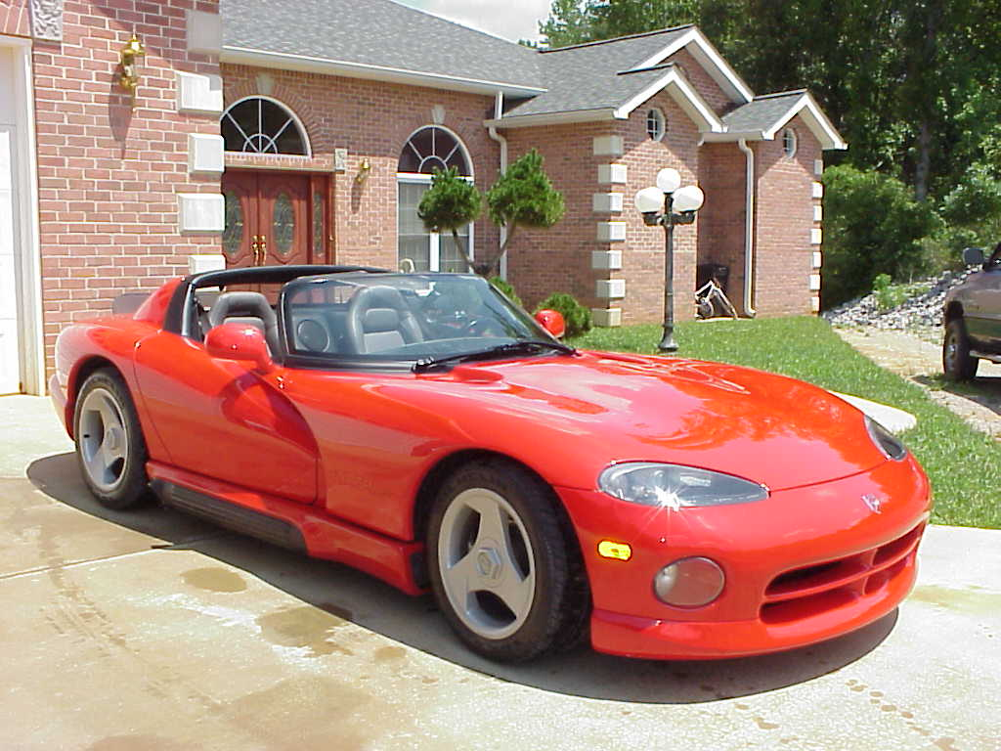
1992 Dodge Viper V10 First Year Production – “Black Belt Bobs Previous Hot Car!
ABOUT THE AUTHOR
Robert Reuter “Black Belt Bob” has worked for some of the biggest name franchised car dealers, privately owned, public companies, CarMax®, GMC®, Pontiac®, Toyota®, Scion®, Kia®, Nissan®, buy here pay here dealer getting 18% interest rate on car loans and went through a certification salesman training testing for the franchised car dealers mentioned.

I have worked 4 years selling new and used cars. Mr. X has over 26 years car experience who contributed his knowledge to my book, not to mention all the salesmen I interviewed. Mr. X is currently selling cars and remains deep undercover to keep his job. I sold 34 cars in my fourth month at Toyota as a rookie car salesman and 30 cars my twelfth month as rookie car salesman. Also, my best day, I sold five cars in one day!

Graduated from Illinois State University with a B.S. degree, double major and a minor in Business Administration and the first person on both sides of the family to graduate college.
1. Construction Technology
2. Safety Engineer

Awards
- Black Belt Karate age 16
- Black Belt TKD age 19
- Brown Belt Aikido

My passion is internet marketing, creating websites, search engine optimization, dominating Google first page, video marketing, social media marketing and helping small business owners get leads. My hobbies include water skiing, working out and lifting weights. Below are a few of my websites.

www.BestResearchSoftware.com
www.RobertReuter.com
www.BlackBeltPublishing.com
www.AskCarExpert.com

www.AskInternetMarketingExpert.com – help small business owners get leads and new customers. I specialize in SEO, dominating top 10 organic locations on Google search engine including Google places. Setting up a social media marketing campaign including Facebook, Twitter, and Youtube. Create video marketing campaigns. I will build your social media websites and video marketing campaigns for you.

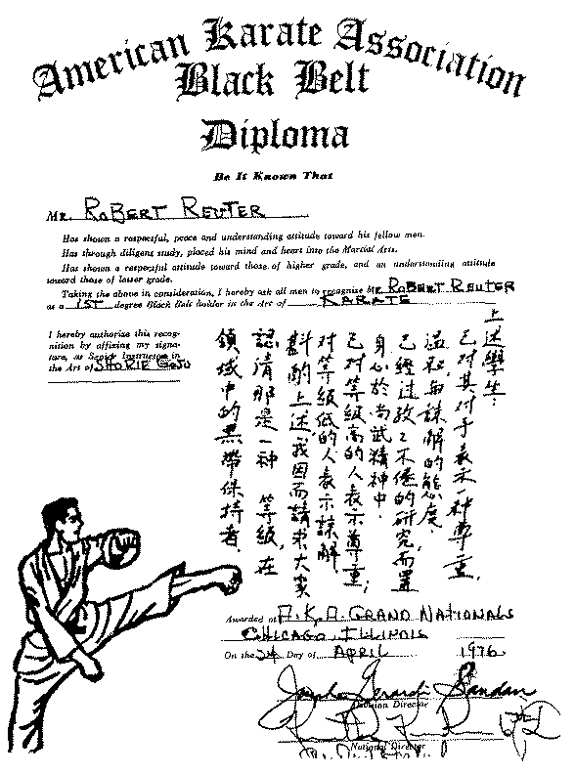
Black Belt Karate Diploma Robert Reuter “Black Belt Bob”

Robert Reuter “Black Belt Bob” Black Belt Bob Aikido Drawing


Black Belt Bob Backwards Barefoot Black Belt Bob One Foot Backwards Barefoot
BEFORE AFTER
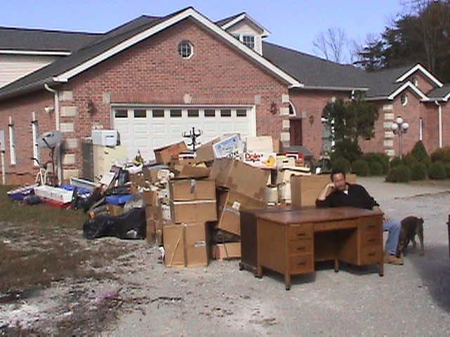
I built this 13,000 SF home, indoor pool with Ex-Wife Throws Black Belt Bob, My Dad,
my bare hands, which took 1 year to build. and My Stuff Out of my Home. Everything I
Own & the Dog Kicked me! Helpless Feeling…

BEFORE AFTER
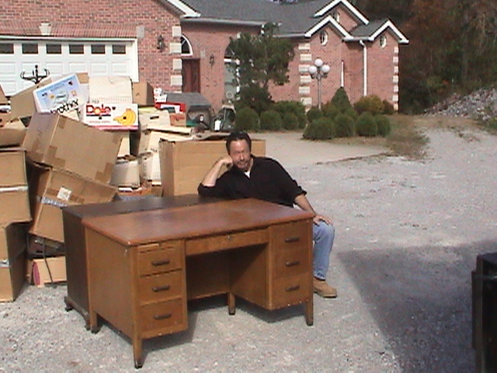
Water view, I lost everything trading stock Black Belt Bob Thinking at His Dads Desk, options, S&P futures options, T Bond options I left His Desk. There Was No Room on the
“I did not lose my ex-wife’s assets just mine” Uhaul Truck!

BEFORE AFTER
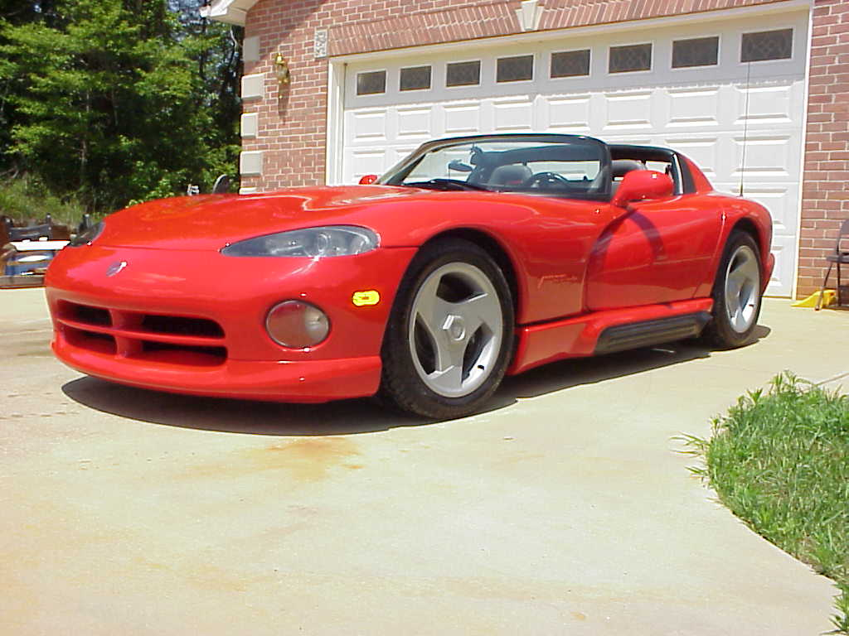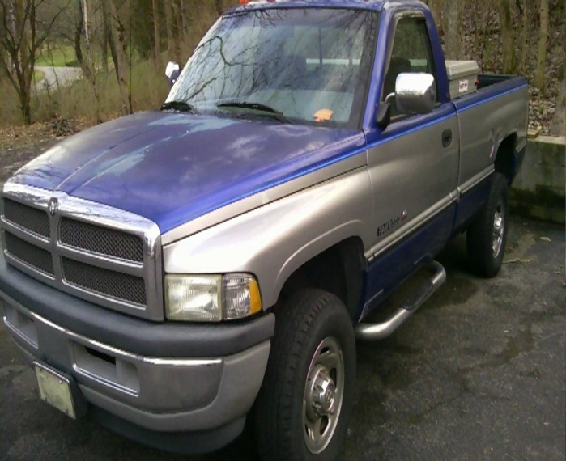
92 DODGE VIPER - FIRST YEAR MADE | 94 DODGE RAM Really I bought in 1996 and and made lots of money with my truck. I drive this today and feel like Sam Walton and Warren Buffet. I just love my old truck
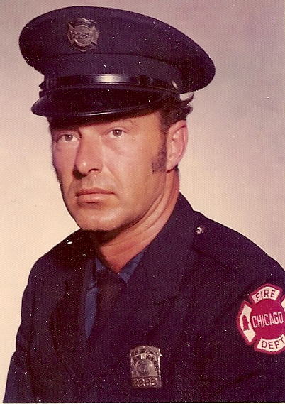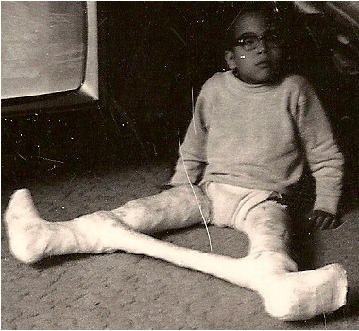
My dad was a carpenter & retired Chicago Fireman Engine 55 who died from lung, liver, & brain cancer. I Love You Dad & Miss you so much! |  | My little brother was born with cerebral palsy and died from stomach cancer at age 32. I don’t have any other siblings. I Love you little brother and miss you so much!

The Eagle Has Landed
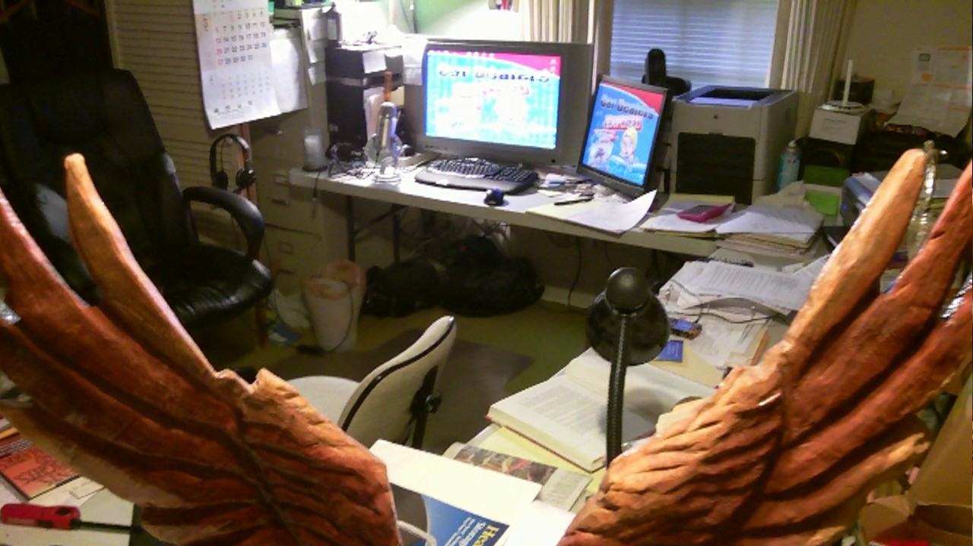
Wrote and Finished My Book Here
I wrote this book and finished it here at my desk. You notice it’s really those plastic church tables I bought at Home Depot. I set up 3 of these tables and surrounded myself to write this book for you. I use two monitors when I work. This makes writing and building websites so much easier.

I lost all my money twice, trading stock options, S&P futures options and 30 year T Bond options. It was a huge financial mistake and I take full responsibility with no excuses. After the loss, I took a job selling cars and did not like what I experienced. Had I not lost the money, I would not have sold cars, and would not have written this book to help the masses. This book will help many people if you apply the techniques inside this book. Life is funny, how events happen in our lives based on Gods plan!

The key is you do the best with what you have and anything is possible if you just set your goal and work hard. Never let your surroundings stop you.

President Abraham Lincoln walked one mile to school each day and read books under a candle light!

The completion of my first book makes me an author joining the distinguished ranks of Benjamin Franklin and Harry Potter “J.K. Rowling”.
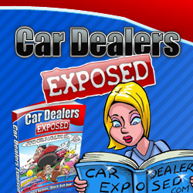
www.CarDealersExposed.com

The intent of this book is to teach you how to conduct your own research when buying a car. There are so many variables based on the make, model, year and mileage for each car. Also, you have to deal with the variables at each car dealer, car salesmen, car sales managers and finance managers. You must study and do your homework to get the best deal, before you approach a car dealer.

Car salesmen are trained with product knowledge and selling techniques to overcome your objections. The car salesmen have a trained team surrounding them. If you don’t educate yourself and conduct as much research as possible you are facing a team of trained auto professionals. If you want to learn with 23 video tutorials, audio, PDF mind map, bonuses visit my website www.CarDealersExposed.com

I want you to go get a cup of coffee or hot tea and take notes while you read this book.


Enjoy your coffee when reading.
Table of Contents

TITLE 1
CARTOON COVER 3
COPYRIGHT – LEGAL DISCLAIMER 4
LEGAL DISCLAIMER 5
TESTIMONIALS 6
ABOUT THE AUTHOR 7
TABLE OF CONTENTS 14
ACKNOWLEDGEMENTS 20
INTRODUCTION – “BUYERS ARE LIARS” 29
The story of the “Prodigal Son is Alive Today” 35
Mr. X 48
Reuter/Congressman’s Name Car Dealer Act 50
Channel 5 News National Journalism Awards Car Dealer Scams 56
How to buy a car for FREE 57
Story How I Got Fired 58
CHAPTER 1 – HOW TO FIND CARS FUEL ECONOMY AND FUEL COSTS 61
CHAPTER 2 – HOW TO BUY OR SELL A CAR USING CRAIGSLIST 66
How to set up a new Criagslist.org Account for FREE 66
How to post your car for sale on Craigslist 72
How to do a targeted keyword Craigslist Search 80
Never accept cashier’s check when you sell your car by owner 81
Make sure the car title signatures match the front 82
One final posting trick to add attraction factor to your ad 83
Special characters for Craigslist Posting 84
CHAPTER 3 – HOW TO RESEARCH ON AUTOTRADER 85
CHAPTER 4 – HOW TO RESEARCH ON EBAY MOTORS 89
CHAPTER 5 – HOW TO RESEARCH CARFAX VEHICLE HISTORY 95
CHAPTER 6 – HOW CAR DEALERS MAKE MONEY 101
How a Car Dealer Makes His Profit – 3 Main Profit Centers 102
New Cars 102
How to Install leather at dealer cost 106
Parts Department 108
Service Department 108
Customer Satisfaction Survey Index (CSI) 109
Used Cars 111

CHAPTER 7 – HOW CAR SALESMAN GET PAID 112
How Car Salesman Get Paid: The Commission Structure 112
How Car Salesman Get Paid: The Commission Structure Flow Chart 114

CHAPTER 8 – THE CAR SALESMAN TRAINING SYSTEM
“10 STEPS TO SELLING YOU A CAR” 117
10 Steps Every Car Salesman Will Use to sell you a car “The Road to the Sale” 117
Step 1 – Meet and Greet 118
Step 2 – Qualify: Find Common Ground 118
Step 3 – Product Presentation 123
Step 4 – Demo Drive the Car 126
Step 5 – Trial Close 130
Step 6 – Negotiate 131 & 185
Step 7 – Close the Sale and Write the Sales Contract 200
Step 8 – T.O. (Turn Over) to Finance Office Manager 207
Step 9 – Delivery 235
Step 10 – Follow Up 237
Here are some typical meet and greet lines a car salesman will use 118
Here is the number one objection response of a customer to a car salesman 118
Here is the salesman’s counter response to were just looking 118
Car Salesman are taught there are only 3 ways to buy a car 119
Why does every salesman have to T.O. 120
Here are some of the lines a salesperson uses to get a T.O. or Turn the Customer Over to the
Sales Manager 120
How to Understand the Big Sticker MSRP 123
How Dealers Use the Supplemental Sticker on Your Trade to Rip You Off 125
What is the Difference Between Rebates and Discounts? 125
How Dealers Use Newspaper Ads to Get You to Come To the Dealer Showroom 125
$50 Mistake Cost Me $1500 - Case Study 127
Salesman Held at Gunpoint Story 128
Finance Games the Car Dealer May Play 132
Channel 5 News Nashville, TN Award - Bill Heard Chevy Scandal 133
Asking for a Discount 134
What to Say to a Salesman Who Ask You Do Have a Car to Trade? 134

CHAPTER 9 – HOW THE PUBLIC WILL APPRAISE THEIR CAR 135
How to Appraise your Car Using KBB or Kelly Blue Book? 135
KBB has 3 appraisal methods 136
1. Suggested Retail Trade Value – Appraisal 6 Steps with Images 137
2. Private Party Value - Appraisal 7 Steps with Images 143
3. Trade-in-Value - Appraisal 7 Steps With Images 150
Comparing the 3 KBB Appraisals Side by Side 156
CHAPTER 10 – HOW CAR DEALERS WILL APPRAISE YOUR CAR 159
How the Used Car Manager Will Appraise Your Car 159
VIN = Vehicle Identification Number 17 Digits Drivers Windshield 159
How to locate the model year from the VIN Chart 160
There Are 4 Different Books That Used Car Managers and Lenders Use That Show Used
Car Values 161
1. Manheim Live Auction 162
2. Black Book 163
3. NADA 164
4. KBB or Kelly Blue Book 164
How The Car Dealer Will Trick You With Book Values? 164
How to Catch the Used Car Manager on the Trade Book Value? 165
How Can You Find Out The Black Book or NADA Value on the Car You Want to Trade in
and on the Car You Are Considering Buying? 165
Here’s an Insider Trick When the Salesman Shows You What Your Trade is Worth. This
One Secret is Worth the Price of This Entire Book 166
The Doc Fee or Processing Fee 167
Solution – How to Get Out of Paying the Doc Fee? 167
CHAPTER 11 – HOW TO FIND THE INVOICE ON YOUR NEW CAR 169
How to find new car invoice and MSRP price 170
Method 1 – Truecar.com 171
Method 2 – Edmunds.com 175
How to know what amount is the dealer holdback? 182

CHAPTER 12 – HOW TO UNDERSTAND THE 4 SQUARE PRESENTATION OF MONTHLY PAYMENTS AND PRICE OF CAR (Step 6 – Negotiate) 185
How to calculate your FICO credit score into interest payment 186
Factor sheet to calculate your monthly payment & interest rate 188
How to figure your monthly payment based on the factor sheet 189
How to know if the finance manager or sales manager is lying about what your monthly
payment should be? 189
How to figure out the interest rate they are using – go to the factor sheet 190
Rule never accept the first pencil on 4 square worksheet 190
Story – I Would Rather Go to the Dentist to Drill My Teeth Then Buy a Car! 191
4 square worksheet case study 191
First pencil on 4 square worksheet 192
Second pencil on 4 square worksheet 195
Third pencil on 4 square worksheet 197
Payment worksheet 199
How to Buy a New Car with No Trade and No Rebates? So Get Your Calculator Right Now! 201
How To Figure The Interest Rate Your Self When The Sales Manager Gives You a Monthly
Payment and You Know The Amount Financed? 201
How to Buy a New Car with No Trade and With a Rebate? 202
How to buy a new car with your trade and no rebate? 202
Trade Difference is The Most Misunderstood Concept 202
How to Buy a New Car with No Trade and No Rebate and With a Rebate? It’s
Always a Good Idea to Wait for Dealer Rebates on New Cars 203
How to Buy a New Car with a Trade with ACV (actual cash value) versus Trade
Allowance with Payoff on the Trade 204
How to Buy a New Car with a Payoff Less Than What They Appraise it for; We Will
Use a $2,000 payoff on the car when you trade? 204
How the Finance Manager Packs The Back End? 205
Why the Portable Car Payment Factor Sheet is Such an Important Tool? Never go to a
Car Dealer without This Cheat Sheet! 205
Some Finance Managers Use This New Trick on You 206
The Finance or Business Office Known as the Finance Manager Time 207

How to Sign All the Legal Documents, You Decide to Change Your Mind and Want to Get
Out of the Purchase Agreement? 208
How to Deal with the Finance Manager 208
Here Are the Steps the Finance Manager Needs to Accomplish 209

CHAPTER 13 – YOUR CREDIT SCORE DETERMINES FINANCE RATES 211

What Do Credit Bureaus, Car Dealers and Banks Use to Determine Your Credit Score and What Terms of Financing They Give You 211
1. CBI/ Equifax
2. Transunion
How to get a FREE credit report? 211
Credit Report/Bureaus Look Something like this 212
Debt to Income Ratio 212
Very Important Tip: Credit Application Secret 213
The New Financing Technique Called Menu Selling 214
What the Credit Score Ranking Looks Like Based on Credit Score Ranges 215
What is Advance? 215
How the Car Dealer Can Charge You a Higher Interest Rate? 216
What is the Bank Retention Rate? 216
How to Stop the Finance Manager From Charging you 1-3% Higher on Your Car Loan Than
You Actually Qualify? This is a Big Secret Tip: 216
How to calculate your monthly car payment? 217
Why Do Used Car Managers Have To Appraise Cars Using Black Book or NADA? 217
Here is an Example with a Trade and With Payoff of $9,000. This is Where Many People Get
Confused 218

CHAPTER 14 – EXTENDED SERVICE CONTRACTS 221
4 Types of Extended Service Contracts 221
Should You Take The Extended Service Contract? 222
I Highly Recommend You Buy Gap Insurance 223
The Finance Contract 223
Secret Tip – Never Let the Finance/Business Manager Rush You without Reading the Entire
Sales Contract 224
Finance Manager – Sign the Contract Sales Pitch 225

CHAPTER 15 – LEASING YOUR CAR VERSUS BUYING 227
The Lease Section 227
Secret Tip of the Rich 227
Most customers care about the monthly payment not the price of the car and salesmen know
this, so they sell payments. You need to be very careful 227
What is Residual Value on a Leased Car? 227
What is Cap Cost on a Lease? 228
Here Are Some of the Tricks Car Dealers Use on Car Leases 228
Many Banks Have an Early Payoff Termination Fee 229
Here is Another Trick for Lease Payments 229
Special/Secondary/Credit Challenged Section 229
This is important 230
Here is Another Big Sales Lie 230
Here’s Your Response Very Important 230
Bank Rate Sheet Swap the Sheet Trick 232
Down payment 232
Why Do Lenders Require Up To 6 References? 233

CHAPTER 16 – THE FINAL STEP DELIVERY OF THE CAR 235

CHAPTER 17 – FOLLOW UP & CSI SURVEY 237

CHAPTER 18 – HOW TO BUY A CAR WITH HORRIBLE CREDIT GUARANTEED 239

The “Buy Here Pay Here” car dealers are known as “Tote the Note Car Dealers” 239
What is a buy here pay here car dealer? 239
Important Facts When Buying From a Buy Here Pay Here Car Dealer 239
How to find a buy here pay here dealer 240
What information will I need to bring to a buy here pay here dealer or any car dealer? 241
Your down payment determines what car you can buy! 241
The down payment is the secret key to buying a car at a buy here pay here car dealer! 242
How to get a loan approval guaranteed at a buy here pay here dealer? 242
What down payment is the best strategy? I recommend the least amount down! 243
Biggest Secret Tip – Never buy a used car from any car dealer or private party unless
you pay a Mechanic for a complete inspection 243
Urgent Warning “Check Engine Light” 243
Test drive the car 244
How to Negotiate the Best Price after the Test Drive 244
A used car salesman is taught to never negotiate price or payments on the lot 245
How buy here pay here car dealers price their cars? 245
How to negotiate the best deal 245
What is we owe form? 247
Car insurance is required 248
Final car inspection is highly recommended 249
How to get out of used car loan that you bought at a buy here pay here car dealer 249
We can refinance your car loan in 12 months is a Big Fat Lie 250

CHAPTER 19 – WHATS THE BEST WAY TO BUY A USED CAR
“THE CARMAX WAY” …251

How to sell your car without having to buy a car? 253
Reasons to Buy a Used Car from CarMax 254
Step 1 – Meet and Greet 255
Step 2 – The Appraisal Offer 259
Step 3 – The Interview 261
Step 4 – Vehicle Selection 262
Step 5 – Vehicle Presentation 264
Step 6 – Test Drive 264
Step 7 – Financing 264
Step 8 –MaxCare Extended Service plan part of Finance Step 7 266

How to Find a Car on the CarMax Website 267
How to Transfer a Car from another CarMax Location? 274
How the CarMax Transfer Process Works 274
Items to bring to CarMax 277

CHAPTER 20 – HOW TO BUY USED PARTS FOR YOUR CAR LIKE THE MECHANICS
AND CAR DEALERS 279

Car-part.com 130 million car parts 279
How to buy used original salvage OEM parts and save up to 60% off manufacture prices at
LKQOnline.com 282

CONCLUSION 283

14 Points of Interest Checklist 286

4 Square Worksheet 289

Payment Worksheet 290

Factor Sheet 291

AUDIO, VIDEOS, MINDMAPS & LOTS OF BONUSES 293

SPECIAL BONUS – BEST RESEARCH SOFTWARE $47 VALUE 294

DO YOU WANT YOUR WEBSITE & VIDEO TO RANK ON PAGE 1 GOOGLE
SEARCH? 295

RESOURCES 296

Here is your free chapter to my new Amazon book

If you would like to buy a copy of my new book $19.99 from Amazon go here
https://www.createspace.com/3594797

OR

If you would like the digital version of my book, 23 step by step video tutorials, MP3 audio, 2 PDF Mind maps, Software and 3 Fast Action Bonuses for $47 then go here to order:
http://www.cardealersexposed.com

CHAPTER 8 – THE CAR SALESMAN TRAINING SYSTEM
“10 STEPS TO SELLING YOU A CAR” 117
10 Steps Every Car Salesman Will Use to sell you a car “The Road to the Sale” 117
Step 1 – Meet and Greet 118
Step 2 – Qualify: Find Common Ground 118
Step 3 – Product Presentation 123
Step 4 – Demo Drive the Car 126
Step 5 – Trial Close 130
Step 6 – Negotiate 131 & 185
Step 7 – Close the Sale and Write the Sales Contract 200
Step 8 – T.O. (Turn Over) to Finance Office Manager 207
Step 9 – Delivery 235
Step 10 – Follow Up 237
Here are some typical meet and greet lines a car salesman will use 118
Here is the number one objection response of a customer to a car salesman 118
Here is the salesman’s counter response to were just looking 118
Car Salesman are taught there are only 3 ways to buy a car 119
Why does every salesman have to T.O. 120
Here are some of the lines a salesperson uses to get a T.O. or Turn the Customer Over to the
Sales Manager 120
How to Understand the Big Sticker MSRP 123
How Dealers Use the Supplemental Sticker on Your Trade to Rip You Off 125
What is the Difference Between Rebates and Discounts? 125
How Dealers Use Newspaper Ads to Get You to Come To the Dealer Showroom 125
$50 Mistake Cost Me $1500 - Case Study 127
Salesman Held at Gunpoint Story 128
Finance Games the Car Dealer May Play 132
Channel 5 News Nashville, TN Award - Bill Heard Chevy Scandal 133
Asking for a Discount 134
What to Say to a Salesman Who Ask You Do Have a Car to Trade? 134
CHAPTER 8 – the CAR SALESMaN training system “10 STEPS TO SELLING A CAR”

There are the 10 steps to a sale that every auto salesperson learns. The 10 steps are taught in various forms at different car dealers however the basics are identical.

I will list them first and then we will go over them on the following pages that explain how they are used on the customers (YOU).

These 10 steps are designed to let the salesperson take control of the sale, not the customer.

That’s about to change because from now on you will be in control of the car buying process! Once you learn how the car salesman sells cars, you will understand how to buy the car.

Here, are the 10 steps you will learn.

The 10 Steps Every Car Salesman Will Use on You Known as
“The Road to the Sale”

- Meet and greet
- Qualify: find common ground
- Product presentation
- Demo drive the car
- Trial close
- Negotiate
- Close the sale - Write the contract
- T.O. (turn over) to sales manager or finance office
- Delivery
10.Follow up

Step 1 - Meet and greet

This is a pretty simple step, because it’s used when you first pull up onto the car lot, and a salesperson or greeter meet you (depends on dealership policy). Some use greeters now so that you will not feel pressured up front, yet they are after the same thing, they will turn you over to a salesperson.

Some dealers require their salespeople to grab customers as soon as they stop there car and will approach the car before you even open the door. Other salesman will chase you thru the lot hoping you stop the car or force you to stop even if you are just driving through the lot.

Here, again is where the dealers have it made, they can make the rules and the salesperson looks like the evil one by trying to jerk a customer out of the car. The bottom line is the salesman are supposed to greet you and then start the sales process.

Here, are some typical meet and greet lines car salesman will use:

Welcome to xyz dealership, my name is, what is your name?
Hey, how you doing, my name is, what’s your name?
Can I help you?
My name is, what car are you looking for today?

Here, is the number one objection response of a customer to the car salesman:
Oh were just looking 99.9% of the time

Here, are the salesmen’s counter responses to were just looking:
Well glad to meet you, I’m the just looking manager to make you laugh and start to like the salesman

or When you met your wife you were just looking, now look at you your married with kids
The salesman will try to ask you specific questions so the communication can start somewhere.

Step 2 - Qualify the Customer: find common ground

This is when a salesperson begins to sell you a vehicle. The reason why i say qualify/find common ground is because of the questions they are supposed to ask you.

All salespeople will ask the same questions, they just may do it at different times during this sales process. They want you to feel relaxed because they are asking normal questions, not really care questions, in order for you to think they actually care about you personally, (no one will buy a car from someone they don’t like).

This is the car salesman’s way to relax you so you like them and are comfortable later when they present car payments so there number one goal is they want you to trust them.

Be under no illusions, while the salesperson may be a nice guy, his one aim is to relax you enough to trust him. His only goal is to make sure that under no circumstance do you leave the lot without buying a car.

If you say “just looking” they are trained to ignore that comment and try to make you like them so you buy a car today!

The salesman wants to find out with qualifying questions (that seem so friendly) the answer to 5 questions in the salesperson’s mind:

Are you willing to buy right now today?
Can i talk you into buying right now from me (without the manager’s help)?
Can you financially buy a car (or am i wasting my time)?
Are all buyers present like the husband and wife if both are signing the loan agreements?
What’s this guy’s credit like and can I get him financed today?

Car Salesmen are taught that there are only 3 ways to buy a car
1. Cash
2. Monthly Payments – they want you to focus here
3. What a customer wants for their car trade in (trade-difference). Then it goes back to either cash or payment.

Salespeople get paid on commission. I know some get a draw (money paid to the salesperson against his commission, it’s usually minimum wage), but it’s not nearly the amount if a car is sold and good profit made.

Baby needs a new pair of shoes…this is in the mind of a salesman…he Needs to sell you a car Today!


Baby needs a new pair of shoes

That’s why they try to figure out if you can buy a car. If you sense this attitude from a salesperson, then it’s up to you if you want to continue or just leave. With this information, you can stay and not let him know you’re onto his game and wait until later to surprise him.

If he thinks you are unaware, and that he is going to make a big profit on you, you will be able to turn the tables during negotiations (you’ll love to watch him sweat when you do to!)

Why does every salesman have to T.O. or turn over to sales manager?

In the event, you decide to leave the dealership or they don’t have what you want, be prepared for the T.O. (turn over) to the sales manager or floor manager.

Every car dealer that i have ever worked for requires this of their salespeople.

The dealer wants someone else to talk to the customer before they leave. This is called turn over T.O. customer to the sales manager. Don’t fall for the “just wanted to thank you” for coming in visit. The sales manager may say that but what he they really wants, is another face to try and make the sale.

Some dealers send in 2 or 3 other faces or enough until you say yes. They try different tactics because they believe that maybe just “another face” will be enough get you to buy, maybe you didn’t like your salesperson etc.

Here is what a sales manager might say to you if you like a car but want to think about it. He will say let me put a license plate on the car and you can take it home overnight. If you don’t like the car bring it back tomorrow no strings attached.

The sales manager does this because you will fall in love with the brand new car not to mention all you friends and neighbors will see your car in the driveway. What will you tell your neighbors when you brought the car back to the dealership without buying losing face?

Here, are some of the lines a salesperson uses to get a T.O. or Turn Over to the Sales Manager
Oops, I forgot my business card inside, let me go get one. Just to get you inside to see the sales manager before you leave. Every salesman carries business cards in their pocket at all times.

My manager wants to thank everyone for coming in.
I will lose my job if i don’t get the sales manager, let me go get him.

Come inside with me and I will get you a brochure. The salesman will walk a lot faster than you so he can get the sales manager at the tower to debrief him on what you like or do not like.

And many more excuses to get the sales manager to talk to you.

Now here is something you need to understand don’t assume that you are talking to an actual sales manager. Many times they will tell a more experienced salesperson to act like a “floor manager”, training manager” and they have no more actual authority to sign off on a deal than the salesperson but their goal is to get you back on the “road to a sale”-the ten steps.

Below are some of the questions you will be asked. It is not a friendly just want to get to know you personally, it’s an attempt to relax you and qualify you as a financially capable buyer of a car while you are visiting the car dealer.

1. Are from around here (local so you may know same people)
2. When he introduces himself he may say something like, my name is john smith the sales manager and you are? If you are alone he may try to find out if you are married or have girlfriend/boyfriend. Trying to find out how many decision makers are involved. If there are more than one and the other one is not there, salespeople know that it is harder to get a signature while the customers is there without consulting the other party.

So the salesman might ask you:

Do you want to take the car to him/her and let them see the car?

Can we call them to let them know about car?

You think they are just being really friendly and going out of their way to help. They want to make sure all parties involved are together so they can get a car sold today. The number one goal is to sell you a car right now and not later.

Some carefully worded financial questions: when they find out where you live, it may trigger either a nice subdivision they know of or and high dollar apartment complex (again qualifying if you have either money or good credit enough to live there). They are trying to qualify you financially now. They noticed also what you drove up in and made assumptions, but they will qualify these later also.

They will ask you if you plan to trade what you drove up in, (I’ll discuss 2 ways to handle this and give you my best idea, but it’s up to you). If you tell them up front that you are trading, then the sale’s route will go something like what follows (this is so they can start analyzing in their head about your trade). Is the car financed, paid off, old, high mileage, and what is your current monthly payment.

They will ask if you intend to trade the car in. Even if you say no, they will ask if it is currently financed and where it was financed at. Higher financial institutions (banks, etc.) generally reflect credit worthy customers is what they think. If it’s too new, ,they will try to find out how much you owe because you may be upside down and owe a lot more than your car is worth.

The salesman will say something like this: Wow, my mom/ brother has one just like your car. Her car payments are xx number of dollars a month (always a high number), do you have to pay anywhere near that.

Remember salespeople are good at pressing ego, and emotional trigger buttons. It makes you proud if he quotes a ridiculous payment and you spit yours out instantly. Now he can easily find out how long you have to go.

Remember there only 3 ways to buy a car and monthly payment are 80% of the three.

The salesman will talk about things like, sports-if you happen to have a team tag on your car, then they can get onto that common ground, anything that will make you and them closer. For example golf, fishing, reading, sports, football, baseball, basketball, etc.

It doesn’t matter if its women or men, all salespeople will try to find common ground.

The easiest way around all of this is to be prepared. Know the questions are coming with an understanding why they are asking them. If you feel okay with the questions, you can choose to answer or not.

In reality, none of these financial questions should be asked until you’ve selected a car in your price range (I’ll show you later how to figure that out). They will say that it’s just to help you get the most car for the money you want to spend.

A very important point when you hear this you will be prepared. Before you had the inside secrets being taught to you right now, you may have fallen for their tricks because this is what every salesperson is taught.

Salesman want to make customers think they are getting the most car for their money when in reality if you can sell them less car for the same amount of money, the dealership makes more profit and that’s the bottom line every time.

Sure reputable dealers want long-term customers, but if comes down to the dealer making $3000 - $4000 profit on a car or worrying about if you will be one of their long term customers, they will take the money every time.

The information inside this book will make you a skilled buyer and the car dealer will cater to you. Because, the only profit they make is what you let them. They will want to keep you as a long term customer.

Why? Because sometimes the dealers receive more money from manufacturers in advertising cost, inventory, etc. Let’s say you buy a car at invoice and dealer makes a little money, they will receive an inventory increase on future shipments. That means for every car they sell the manufacturer will send them 1.25 cars. For every 4 cars sold they get 1 more new car for the new car inventory.

You will be a number person, not a person they killed (dealer terminology for a high profit (gross deal), which isn’t bad at all. You don’t get ripped off at all and the dealer tries to keep you happy.

Step 3 - Product Presentation

This is a simple process when the salesman will wow you with all these product knowledge facts about the car’s safety, performance, quality, etc. Remember, the salesman has been trained by a 100 year old perfected sales system so product knowledge is a requirement for certification in order to sell cars.

The whole purpose for the product presentation is to build value in the car it’s not just a number. They will say something like imagine driving this car home. What will your neighbors think about your new car (they want you to mentally take possession in your mind). Imagine driving this new car when you pick up your boyfriend or girlfriend in this babe mobile. Imagine how you will save money on gas prices. Imagine you driving this convertible with the wind blowing thru your hair total freedom!

To be honest with you, the majority of customers are not as concerned about product knowledge as they are about the price and monthly payments. Most times they already know what they want.

Now either you have told him the price range you want (you will already know close on how figure out your budget, what price fits and the amount you will finance with or without a trade-in: I’ll show you later how to figure this out). The salesperson will not like this because you will be in control instead of him, but what can he do, he has to try to sell you a vehicle.

This next part is very important: one of the basics you need to know about new and used cars and how they mark them up.

How to Understand the Big Sticker MSRP

A new car has to have a factory sticker on it. It shows the manufacturer suggested retail price “MSRP” generally on the right, bottom corner.

Some car dealer’s use a supplemental sticker and it can be used if the dealer has added aftermarket items like spoilers, chrome wheels, but don’t be fooled.

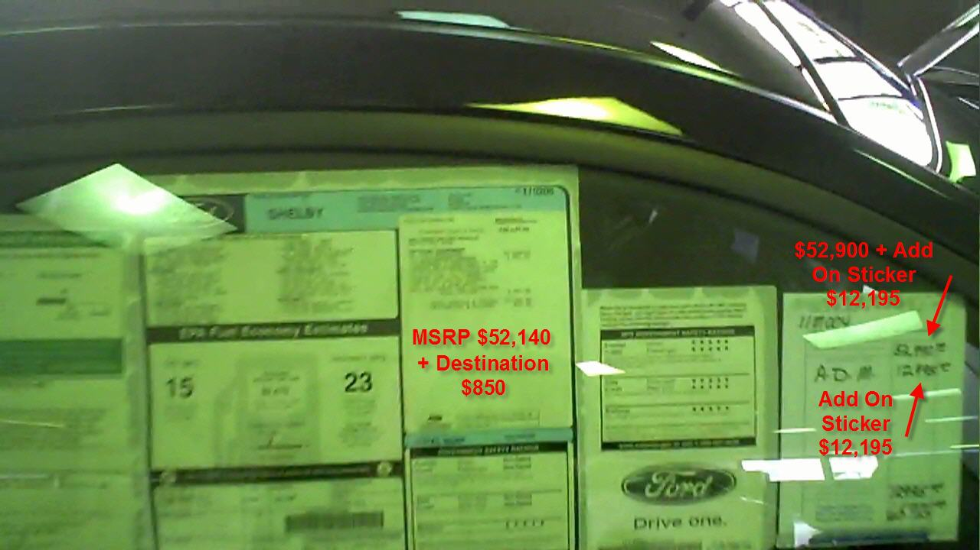
2010 Carroll Shelby Mustang Add on Stick $12,195 Premium

Dealers can mark these up as much as they want and any way they want, there is no regulation. The car dealer may only get one or two Carroll Shelby mustangs in one year so they add a premium price to the car.

If the supplemental sticker has something added be aware they are more than likely 50% - 1000% marked up and stuff like undercoating, paint protection shield, etch, etc. and the cost is minimal.
I know one place i worked, the cost of etch was a bottle of ink and stencil stickers. The stickers cost $10.00 yet they charged $299.00 for the extra etch stickers. See my point.

How Dealers Use the Supplemental Sticker on Your Trade to Rip You Off

They use the supplemental sticker to increase the profit margin on the vehicle to either compensate when someone owes more on their trade than its worth (upside down – means you owe more on the car than the acv -actual cash value - not trade allowance-acv and trade difference explained later) or to offer a bigger discount (whoopee) on the car.

Case Study – You do research at home and find Kelly Blue Book (KBB) says your car is worth $5,000 but you owe $7,000 on the loan so you are upside down $2,000. The dealer has a supplemental sticker with $3,000 add on profit. So now the salesman will say what if I give you $7,000 for your car and pay it off will you buy today? You see the dealer is playing with inflated supplemental sticker and still has $1,000 profit on this add on sticker alone plus the difference between invoice and MSRP.

Secret Tip – Test the salesman and say OK give me $7,000 for my car minus the supplemental sticker and see what happens?

I’ll show you how to get around that or at least make sure they don’t “kill you” by using this sticker. Base your decision on what you want to pay based on the MSRP. The more the car costs, the more the mark-up but generally 10-15% is a reasonable assumption on anything under $20,000. Over $20,000, give yourself and extra 5% and over $30,000 and extra 2%.

So if, a car has an MSRP of $15,000 that means that the dealer paid the manufacturer (who built the car) about $12,750 for it. This is the rough number you want to work up from before rebates (if available).

What is the Difference Between Rebates and Discounts?

Rebates and discounts are two different things.

Rebates - are money the manufacturer is offering on the car.
In Tennessee, you have to pay taxes on the rebate, so don’t fall for the trick that you get all that money because taxes are collected on it (I’ll show you how later). Now some other states may do rebates and taxes different but this book is to give you a basic knowledge that will save you money on their tricks.

You can figure the tax and rebate pretty simply by how your state operates.

Discounts - are what the dealer is willing to reduce the price off the cars MSRP and Supplemental sticker.

How Dealers Use Newspaper Ads to Get You to Come To the Dealer Showroom

When you see an ad price on a car in the newspaper or internet, TV, etc. the dealer has generally used the rebate plus his discount (if he uses a supplemental sticker, he can mark a car up to any amount and then act like it’s a huge discount). When you see a low price for a car in a newspaper ad that is usually for one car and it will be sold when you get to the car dealer (loss leader). They will then try to upgrade you into a better car that cost more money by telling you the car in the ad was sold and was a base model.

When you figure out the price range you can afford, figure it out off of the MSRP (supplemental only if there are real things added like, spoiler, wheels, thing you can touch on the car (not paint sealant, undercoat, etc.) and figure they are marked up minimum 50% on up.

So our $15,000 car probably cost the dealer $12,750

If there is a supplemental sticker it could be anything. So that is why i warned you. I am going to show you how to figure your numbers always based on MSRP, invoice and rebates.

Step 4 - The Demo-Ride

Very Important - The most important advice I can give you if you are buying a used car ask is to ask the dealer if you can have your mechanic look at the car. If the dealer says no, DO NOT, BUY a CAR FROM HIM.

If the dealer says ok no problem, as long as you pay your mechanic the fee. The dealer may tell you set up an appointment with your mechanic and the dealer will send the lot attendant to sit with the car for 1 hour at your mechanics shop.

Plan on paying your mechanic $75 to $100 to look at the used car you are buying but this will save you thousands in hidden repair costs. Used car dealers sometimes will turn off/reset check engine or service engine lights on purpose. If you hire a mechanic, he will find these check engine codes turned off and reset. Sometimes the service engine soon light could mean change the oil or a scheduled maintenance is required. It’s better to know exactly what the light means than to take the risk.

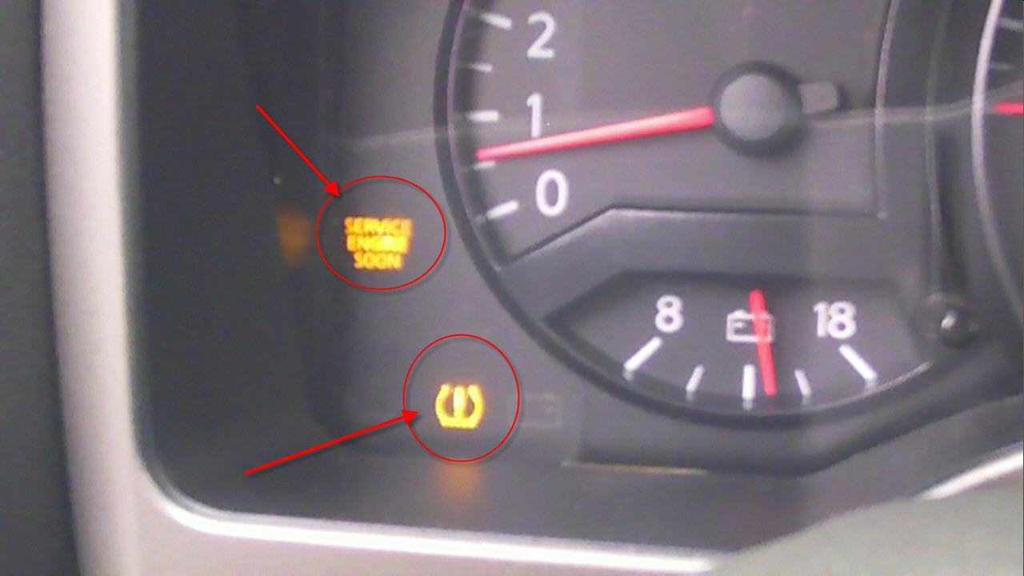
The top light is Service Engine Soon and bottom light is tire pressure monitor

If the check engine light code has been turned off or reset it will come on about 75 to 100 miles, so if You bought this used car your check engine light will come on at about 75 miles and guess what you bought the car as is and will have to now pay to fix the car you just bought. The dealer will say I did not know about the check engine light which is a big fat lie but hard to prove.

Very Important - A used car will not pass emissions testing if any check engine lights are on, so you will not be able to get a license plate until the car passes emissions test.

Most Important Tip In This Book - This is the most important advice I can give you when buying a used car, pay a mechanic $75 to $100 for an inspection before you buy that used car and he will give you an itemized report with costs to fix any problems. So what if you don’t buy the car, losing $75 is better than getting a car that needs thousands in hidden repairs? Never fall in love with a car or get emotionally attached.
Case Study - Stupid $50 Mistake cost me $1500. I bought my daughter a used 1997 Honda Accord for about $4,000 that I took on trade. Before I bought the car, I test drove the car and everything was working. I sold this customer a new truck and took his 97 Honda Accord in on trade so I immediately told the sales manager I wanted to buy this car for my daughter.

Two months later my daughter was driving to college about 2 hours away. The Honda Accord broke down. She was stranded at night, no help and as a parent you are so worried about her safety. Then her mom had to drive 2 hours to pick her up.

She towed the Honda Accord to the Honda dealer and one cylinder was bad costing about $1500 to fix it. Four months later that same cylinder that Honda fixed went bad again and they fixed it free this time so we sold the car and bought her a $15,000 Nissan Altima to get her thru 4 years of college.

My biggest mistake was I could have paid the dealers mechanic $75 (as an employee I would have only paid $50) for a mechanic inspection, but I did not and based it on my visual experience which was a costly mistake. How could this Honda Accord break down when I personally test drove it? Conclusion, pay a mechanic $75-$100 to inspect the used car before you buy it, no discussions just do it!!!

Most salesmen are required to make a copy of your driver’s license for the test drive for legal reasons so don’t be mad! The dealer wants to make sure you have a valid driver’s license if you test drive their car and just in case you try to rob the salesman he may never come back so they have a way to track you down.

Salesman held at Gunpoint Story – I know a seasoned veteran salesman “Jack” who went on a test drive, when he got out of the car to switch drivers, the customer pulls out a gun and says give me your wallet and keys. Then he said give me your cell phone and get inside the trunk. The salesman knew if he got inside the trunk he would surely die.

Then the salesman got his cell phone and threw it up in the air at the customer and started running for his dear life. Two hours later that customer stole the car and robbed a bank and got caught. Now you see why the dealer needs your driver’s license and insurance card. That salesman begged me to teach him martial arts knowing my training. So I Black Belt Bob taught him some Killer moves.

Story – I know a salesman who was test driving a 4 door pickup truck and the customer driving was only 18. The 18 year old lost control on a turn and yanked the steering wheel and hit the ditch and flipped the truck head over heel. The salesman cracked the windshield with his head, broke his ribs and the $30,000 truck was totaled.
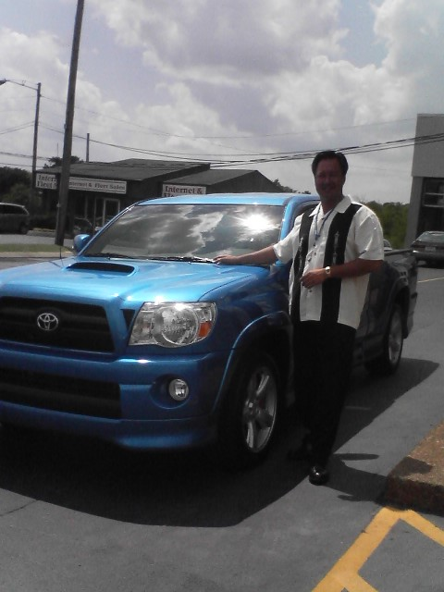
Black Belt Bob by Toyota Tacoma Sport Edition Limited Edition

Now it’s time for you to go on the test drive. Normally the dealer wants the salesman to drive off the lot. Either you will drive off the lot or the salesperson will and you will trade spots somewhere down the road. Most dealerships or salespeople have routes that are designed for them to take. Some dealers will let the customer test drive by themselves because they need the salesman on the lot, usually for small car dealers with only a few car salesman.

Test drive hints: Testing the AC

If it’s hot let the car cool down first, then ride with the window down and turn the air off for a mile or two so you can listen to the car. If the salesperson has turned the radio on-tell him or her to turn it off.

You can check that when you get back. Turn the A/C on while driving with the window down to listen if it makes a lot of noise when compressor comes on, especially on used cars.

If the car or truck has 4 wheel drive make sure the 4 wheel drive works.

Even if it’s summer time-check the heater, check oil and fluids.

I would check the brakes and the ABS or anti-lock brakes on a side road. I would slam on the brakes real hard and you will feel the brake start to pulsate rapidly that tells you the ABS kicked on. Don’t be afraid it’s a test drive. Lots of times brakes will squeak from sitting on the lot and not being driven so test the brakes real good.

Secret Tip – Never Tell the Salesman You Love the Car or They Will Knock Your Head Off and Not Reduce the Price of the Car.
Even if you absolutely have fallen in love with the car (and there’s nothing wrong with that at all) just make sure that on the test drive you don’t smile, or give away anything to the salesperson about your intentions and do not do not ever say “I love this car/truck” it puts you in a negative negotiating stance. Keep your poker face and show no emotions in fact I recommend say it was ok even if you loved the car.

You always want to maintain control of the sale because the salesperson is always going to be trying to get control back.

A sales manager will always chastise a salesperson if he doesn’t quote “have control of his customer during the sales process” they say things like “we do this for a living, they don’t” (except now your armed with better knowledge!)

If it’s a used car and the salesperson says it had an inspection of xxx number of inspection points, ask him to produce the service worksheet, cars that are checked should have a check sheet. If it’s Saturday, they still should have one in the file on the used car. Tell them if they can’t produce it, then you want them to put into writing that you want to take it to a mechanic. Make sure you get a copy of the inspection sheet if you buy the car.

Step 5 - The Trial Close:

This is when you just get back to the dealership or maybe a little before and the salesperson is now trying to make sure to get you inside the showroom to his desk and be pretty sure he can talk you into signing a buyer’s order.

The salesmen will say something like: well Mr Jones, did you like the feel and the way the car drove? You say yes and the salesman will say, “If i could make the numbers work, would you like to take it home today?

This is the spot where either you want to keep shopping by looking at other car dealer lots or you may be seriously considering this one. Remember you will have a pretty good idea about what price you’re going to try to buy the car for, your trade value, interest rate, and payments based on the interest table in this book. So if you want to try to deal and buy the car, that’s up to you, but if not this is a good time to stop and go compare.

If you do decide to leave, be prepared for a barrage from the sales management team. After all you drove the car “they just want to know what it would take to earn your business now”.

If you want to shop, hold firm, get a business card and leave.


Tell the salesman Stop

Beware of the next thing that could happen:

This is one of the reasons i am writing this book. If a salesperson or manager knows you are not willing to commit to buying now, they may give you a low-ball price on the car they are selling because they know you’re leaving.

Very Important Secret Tip - So listen very, very carefully how the salesman or sales manager will phrase these questions by asking YOU a hypothetical “What If” Mr. Jones, “what if” I could sell you this car for xxxx dollars(extremely low price-too good to be true) right now would you take it home. All everyone ever hears is the super low price.

Not the sneaky what if i could, so when you come back because he knows that the price was too low for anyone else to beat. He does this because you’re shopping price and very soon you will get tired of shopping, running out of time, and frustrated.

He will remind you that what was said what if i could, not i can, sell it for this price, but now you just either want that car or go home. This low price, sticks in your head all day while you shop other dealers and end up coming back to the dealer who told you what if only to be surprised that he said what if. Now you go back into the negotiation cycle until they wear you down until you say OK I will buy today.

Don’t negotiate now unless you absolutely want that car because you are tired, frustrated, and impatient.

Step 6 – Negotiate

If you decide you want to buy the car, then this is where you go inside and sit down at the salesman’s desk and begin doing the paperwork. This is where he’ll write down the price of the car and ask you questions about how you want it titled, addresses, etc.

He will take a credit application at this time if you plan on financing. Some dealers take a five line credit application (name, address, work, phones, SSN) if you write a check to pay cash with no financing. If it’s during business hours and you intend to write a check, tell them to verify the check up to xx number of dollars. If you think you’ll be spending $15,000 tell the dealer to verify it up at least $3,000 more if possible.

This is in case you decide you want to purchase some extended warranties, insurance and accessories in the finance office. You know you will already have the money available outside of the dealership instead of doing a five-line credit application.

That way they can’t run your credit check without permission because you are paying cash for the entire car.
If you do fill out a credit application: make sure you get a copy of the credit application and make sure that everything is like you told the person taking the credit application (especially the income areas) even if you do not buy a car.

Why? I have heard stories sometimes the salesman or sales manager will fill in a higher income level on the credit application if your debt to income ratio is too high. Remember what I told you, the salesman will do anything to get that commissions and units sold for his monthly bonus level targets.

By the way, when the dealership runs your credit report it shows for the last 3 years everywhere you have applied for credit and the date you applied.

So if your shopping at different car dealers and getting your credit report ran, they will know they may be competing against other dealers.

Also the credit report shows if any banks have inquired about you. This could work against you, if you tell them you are getting your own financing. You see a dealer wants your finance business so they will give up the front end profit, and let you buy the car at invoice, if they know you will finance the car with the dealer. They will make money on the backend interest rate spread, gap insurance, accessories, and service.

Why? Because they will have a second chance to make money on the back end or financing. However, the tricks I teach you will prevent the dealer from making money on you.

Secret Tip - Don’t sign a thing in the finance office until the finance manager acknowledges he will have to give you copies of everything!

Here’s why? Sometimes, the sales manager will approve a loan that is questionable meaning not sure if the bank will approve the loan. So the Sales manager will say roll the loan. The finance manager has to process the loan. Here’s what could happen later, you might have to return the car.

Finance Games the Car Dealer May Play

You may get a call from the salesman in the next 5-10 days telling you need to come back to the dealer to resign the loan based on the bank requirements. When you get to the car dealer the finance manager will say the bank rejected the original loan but will do it for 2-5% higher interest rate. Here you thought it was a done deal to later find out your monthly payments are going up.

I have heard horror stories, where the dealer will actually sell the car you traded when they are not supposed to. So if you decide you do not want to pay the extra 2-5% higher interest rate and you want your old car back its already been sold.

The dealer is supposed to put the trade in a special location and not sell the car in case the bank rejects the loan and must return your car back to you.

Story – I heard about a car dealer Bill Heard Chevrolet (No Longer in Business) who took a person’s trade in and sold him a new car. The dealer sold the trade car and then got a bank rejection on the loan. The dealer then had a tow truck go get the new car this guy just bought so when he went to go to work the new car he just purchased vanished. This customer went to the car dealer to get his old car back and the dealer wanted to sell him another new car and he said no. They refused to give him his money, his trade and he went to the local news station. They did a big expose review on Channel 5 News here in Nashville, TN. Then the TV station got tons of letters and calls telling them similar stories from the same dealership. This led to a nationwide investigation closing all Bill Heard Chevy dealers in the USA.

Channel 5 News in Nashville, TN won National Journalism Awards for their investigate reporting on Bill Heard Chevrolet.

Here are a few links if you want to investigate Channel 5 News in Nashville, TN
http://www.newschannel5.com/story/5408231/bill-heard-hit-by-consumer-complaints-nationwide

http://www.newschannel5.com/story/6658968/bill-heard-investigation-receives-national-journalism-awards

http://www.ripoffreport.com/directory/bill-heard-chevrolet.aspx?p=3
http://www.newschannel5.com/story/5653569/loan-applications-falsified-at-bill-heard

Bill Heard Shuts Down Remaining Dealerships – Channel 5 News
http://www.newschannel5.com/story/9067758/bill-heard-shuts-down-remaining-dealerships
Message Reveals Attitudes Towards Dealer's Customers – Channel 5 News, Audio Tells Customer You Just Got F…ked
http://www.newschannel5.com/story/5642879/message-reveals-attitudes-towards-dealers-customers

Sometimes, the finance manager will call and say they need you to resign the loan at the same payments and interest rates with another bank or lender which is OK because you’re not paying more money.

Always, get a copy of everything you sign in the finance office and the credit application (do not fall for “we mail everything to our customers”). Tell them they can still mail you copies but you want copies before you leave too and this will piss off the finance manager. Make sure you tell them upfront and the finance manager understands that he is to give you copies.

Even if you have to wait a little longer for your copies just make sure you get all copies signed.

Secret Tip – If the finance manager does not give you copies do not drive the car off the lot because you have not taken possession of the vehicle. The salesman will tell you in the middle or end of the deal hey lets go fill your new car up with gas and have you drive to the gas station which means you took possession of the car by driving it off the dealers lot. Therefore, if the deal goes bad in the finance office you took possession of the car.

Asking for a discount

We’ve covered how cars are marked up and if you don’t have a car to trade use the examples below. Remember to only work your deal off MSRP unless the supplemental sticker has actual stuff added (spoilers, etc.) and after you get a good deal then get your rebates. Don’t let them say the discounts include all rebates. Always work them separately.

Car Trade-ins - Probably the least understood process by the general public. I will show you how they are generally marked up and how dealers manipulate the different books to make you think your deal is so great.

My personal advice on this subject is when you are asked if you are trading in your car say “no”.

What to say to a salesman who ask do you have a car to trade?

YOU say “May Be” (Remember the dealer trick “What If”) you are giving it to you mother, brother, sister, kid etc. until almost near the end of the negotiating. That way you can work on the discount off the car first and get all you can get and then throw the trade in on them later. Tell them you changed your mind.

It’s a small mistruth but you “may be giving it”. Remember the dealer is doing the same to you at almost every turn. They will hate it, but then you can make sure you get the ACV (actual cash value) which is explained below for your trade-in.

Note: when you bring up your trade at the last minute the salesman, sales manager will be pissed off and could give you a lot lower value for your trade by telling you its better to sell it by the owner to teach you a lesson. If you don’t trade you lose the tax savings on your traded vehicle because you only pay tax on the trade difference.
Order My New Amazon Book

Option 1 – Order the Paperback Copy from Amazon

If you would like to buy a copy of my new book $19.99 from Amazon go here
https://www.createspace.com/3594797

OR

Option 2 – Order from my website

If you would like the digital version of my book, 23 step by step video tutorials, MP3 audio, 2 PDF Mind maps, Software and 3 Fast Action Bonuses for $47 then go here to order:
http://www.cardealersexposed.com

My Blog Visit
http://cardealersexposed.com/blog

